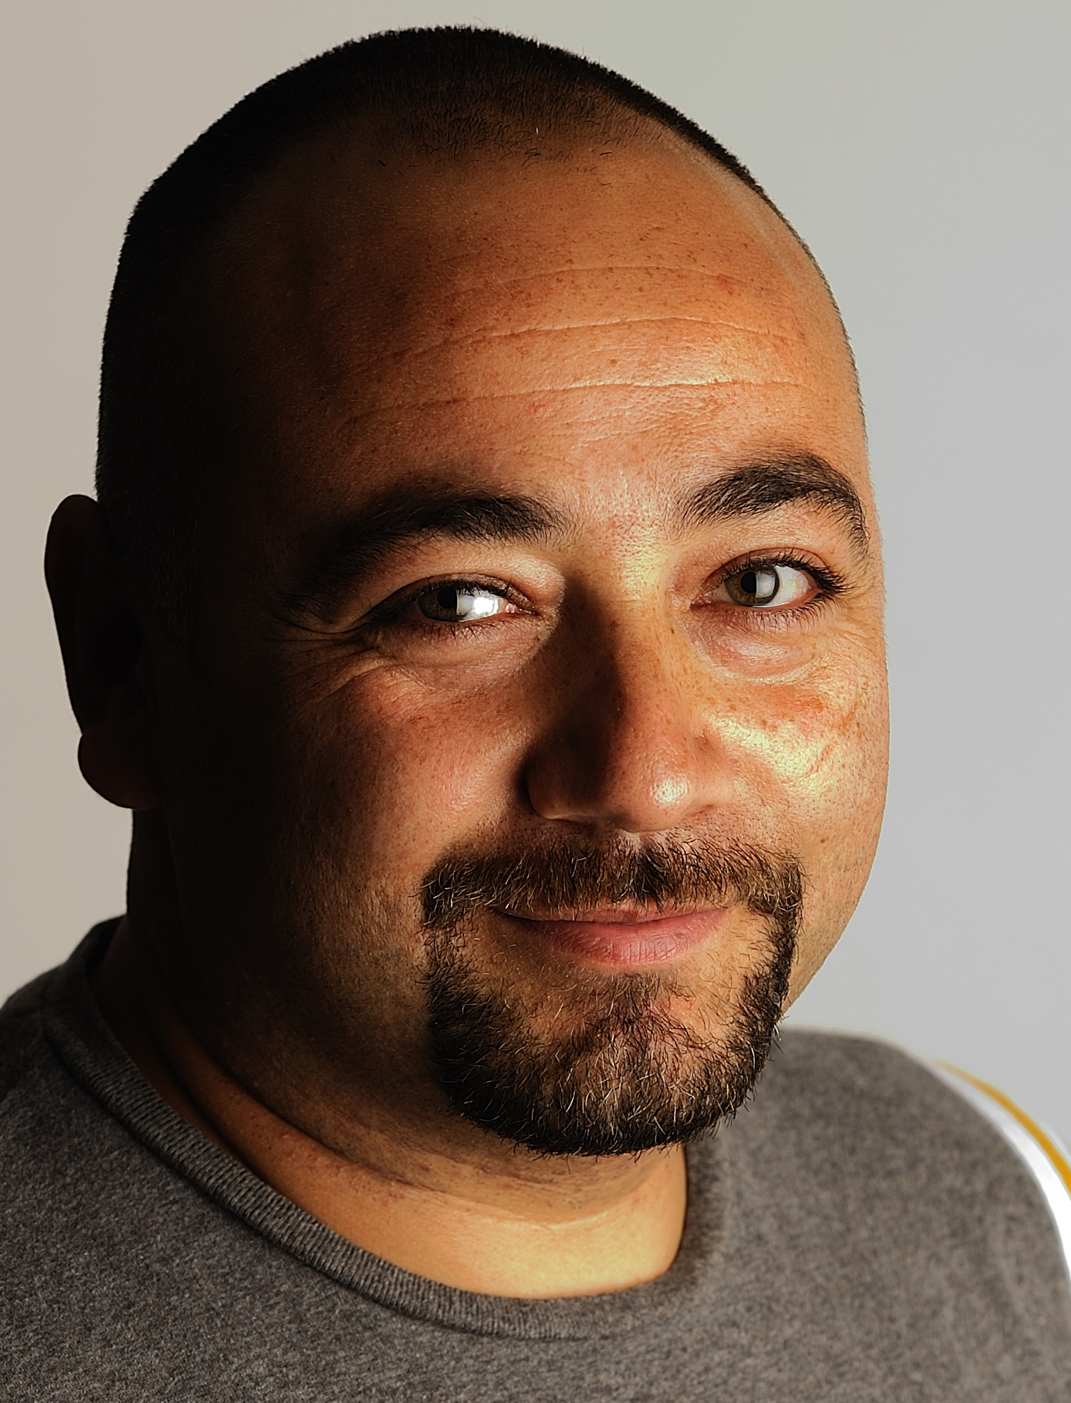
BARIŞ ALADAR

Atakoy 9-10 kisim Hanımeli cicegi sok No 3H A16-B Blok kat 11 D130
Bakirkoy- İstanbul
0 (532) 652 00 74
baris.aladar@gmail.com

Director, Cinematographer

Objective

Seeking a challenging position that will best utilize my skills, knowledge and experience…

Qualifications
- Making and managing content creation and production phases of TV programs/shows.
- Professional camera use.
- Editing.
- Being able to act with fictional logic during shootings.
- Availability of traveling internationally.
- Planning, organizing and following projects.
- Ability to work as part of a team or as an individual.
- Accustomed to tight deadlines and high-pressure work environment.

Special Skills

- Experienced in all MSOffice and Windows Applications.
- Fluency in written and spoken English and Turkish

Professional Experience

Freelance – Cinematographer- Cameraman - Istanbul, Turkey October 2016 – ………….

- Freelance shootings for different TV Channels, TV Programs and Firms.
- International and local shootings of a program called “Ayhan Sicimoğlu ile Renkler” (Colors with Ayhan Sicimoglu) for Bloomberg HT, BeIN İz Tv and BeIN Gurme

WORLD TRAVEL CHANNEL - Istanbul, Turkey (www.worldtravelchannel.com.tr)
Director – Director of Photography January 2011 – October 2016

- Working as a director in all the programs aired on World Travel Channel which is a part of MediaSA Holding. Directing and managing all the content, video shootings, editing and promotion of all the programs include presentation of countries, cities all around the world, tourism programs, cuisine, travel, hotel introductions.
- Working as a director and cinematographer of famous host Ayhan Sicimoğlu’s GUSTO program aired on “World Travel Channel.”

FİLMEKİBİ LTD. ŞTİ. - Istanbul, Turkey (www.filmekibi.com.tr)
Cinematographer- Cameraman July 2010 – January 2011

- All studio and actual shootings of DShopping TV Teleshopping show.
- Shootings of Planet Kitchen TV Channel.

NOPLE PRODÜKSİYON - Istanbul, Turkey
Cinematographer- Cameraman January 2010 – July 2010

- International shootings of a program called “Nihat & Figen” which was sponsored by Garanti Bank and Turkish Airlines.

Freelance – Cinematographer- Cameraman - Istanbul, Turkey October 2008 – January 2011

- Freelance shootings for different TV Channels and TV Programs.
- International and local shootings of a program called “Ayhan Sicimoğlu ile Renkler” (Colors with Ayhan Sicimoglu) for Sky Türk TV and İz Tv

DOĞAN TV HOLDING A.Ş - CNN TÜRK (www.cnnturk.com) - Istanbul, Turkey
Head Cameraman November 2007 – October 2008

- Coordination of all crew and equipment for CNN Turk Program Department.
- Actively involving in all program shootings for CNN Turk Program Department.
- Preparing proposals and presentations for all technical equipment to be used by the crew.

DOĞAN TV HOLDING A.Ş - CNN TÜRK (www.cnnturk.com) - Istanbul, Turkey
Producer - Cameraman August 1999 – October 2007
- Shooting of all subjects to be covered, guests, outdoor, details and etc. for CNN Turk news channel.
- Producer of auto shows and a pet show called “Dostlarımız (Our friends)” for CNN Turk news.
- Shootings of documentaries for the program department of CNN Turk.
- Being the official TV Cameraman for Formula1 for 2006-2007 at CNN Turk Sports service.
.

CINE 5 - Istanbul, Turkey
Cameraman July 1997 – October 1998
- Sports cameraman at Superspor Tv/Cine5 Tv Channel

SHOW TV – Istanbul, Turkey
Cameraman June 1996 – July 1997
- News cameraman in “Show Tv News department”.

Education

Marmara University Faculty of Communication –TV Radio and Cinema - Istanbul, Turkey September 1993 – June 1998
Sarköy Highschool – Tekirdag, Turkey September 1987 – June 1990

Personal Information
- 25.07.1972 – Istanbul, Turkey
- Married and has a son.
- B and A2 Class Driver’s License
- References available upon request.
- Register Have Schengen, USA and Canada visa’s.

